Covid-19
Operations Policy
Booklet

This document contains separate Operation Policy’s for different Businesses and their individual Operational situations.

Covid-19 Operations Policy Document Flow-Chart
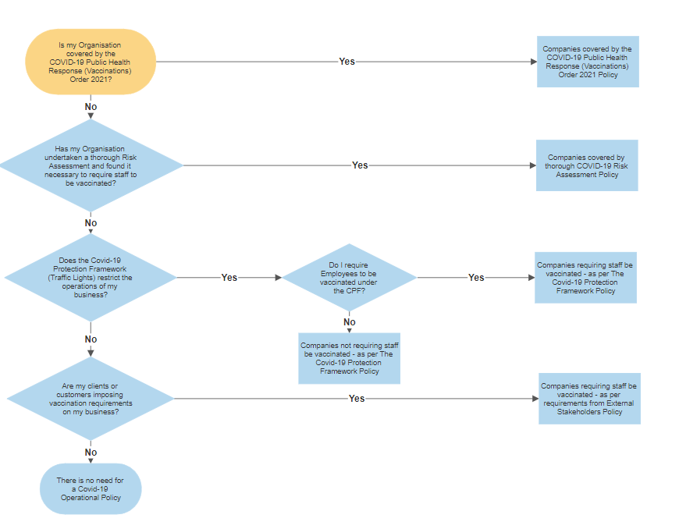

Contents
Companies covered by the COVID-19 Public Health Response (Vaccinations) Order 2021 4
Companies covered by thorough COVID-19 Risk Assessment 7
Companies requiring staff be vaccinated - as per The Covid-19 Protection Framework 9
Companies not requiring staff be vaccinated - as per The Covid-19 Protection Framework 11
Companies requiring staff be vaccinated - as per requirements from External Stakeholders 13

Companies covered by the COVID-19 Public Health Response (Vaccinations) Order 2021

Objective: | To provide information and expectations regarding operations and vaccination requirements for our business, in accordance with the COVID-19 Public Health Response (Vaccinations) Order 2021.
Applicable to: | All Employees, volunteers, contractors, and visitors as appropriate.
Definitions: | Affected Employee is someone who is in a role that is required to be vaccinated.  Vaccinated means someone who has a current valid Vaccination Pass or equivalent.

Key Points: | - The Government have implemented a range of Vaccination Mandates for certain industries and workplaces. Our organisation falls under the [industry type] category and, therefore, require all/some staff to be fully vaccinated in accordance with this mandate.  - The following roles are affected by this mandate:  - XXXX  - XXXX  - XXXX etc  - If your role does not fit in to any of the above categories and you have not been advised otherwise, you are not legally required to be vaccinated but may be subject to other health measure to ensure the safety of all concerned.  - The Ministry of Health is obligated, under the Covid-19 Public Health Response (Vaccinations) Order 2021 to keep a register of those vaccinated.  - Under Sections 10 to 12 of the Order, the Employer is obligated to supply the Ministry of Health with information about Affected Persons and their role within the business and whether or not they are affected by the mandate.  - On signing this document, the Affected person authorises the Employer to supply relevant information to the Ministry of Health for the purpose of maintaining these legal records. This includes the affected person’s full legal name, date of birth, telephone number and email address by which the affected person may be reached. The Affected Person also authorises the Employer, as the PCBU, to access the records from the Ministry of Health to determine their vaccination status, including the name of the Covid-19 vaccination they received and the dates on which they received them.  - If the Affected person works in an affected role and is not medically exempt from the mandate, failing to be vaccinated will lead to removal from an affected role, including up to termination of employment.
What does this mean for your employment? | - The terms of Employment for Employees who are fully vaccinated will not be affected by this policy, unless affected by other change processes.  - If an affected Person exercises their choice not to be vaccinated other than for reason of being exempt, the Employer will consider the redeployment of the Affected Person, where possible, to a role that does not pose a risk to their health or the health of others. Where this is not possible, the Employer will consider whether or not it is practical for the Affected Person to use PPE to minimise the risk to their health or the health of others.  Failing this, an Affected Employee’s employment will be terminated, giving the amount of notice as set out in Schedule 3A of the Employment Relations Act, on the grounds of refusing to be vaccinated as per this Order.
How will we keep you safe? | - We will operate under the appropriate public health measures, in relation to social distancing and sanitation.  - We will require all people who come onto the premises to scan in with the business QR code.  - We will provide all Employees with the appropriate PPE, as necessary.
Scenarios to consider: | - If an Affected Person is found to be circulating anti-vaccination material and/or other anti-vaccination messages to other affected staff, either at work or in a work-related context, they will be found to be in breach of policy and may be subject to disciplinary action.  - If an Affected Person is exempt from the mandate, the Employer is obligated to confirm that this exemption has been legitimately given by an approved Health Practitioner. The Affected Person agrees to the Employer making enquiries with the relevant people (such as the Health Practitioner who has granted this exemption or the Ministry of Health), as appropriate, to confirm this.  - If an Affected Person is exempt from the mandate and is not vaccinated, the Employer will comply with any guidance given by the government from time to time. Inter alia this will include considering the redeployment of the Affected Person, where possible, to a role that is of less risk to their health or the health of others. Where this is not possible, the Employer will consider any appropriate PPE that the Affected Person could use in the course of their role to minimise risk to their health or the health of others.
_________________________________________________________________________
I hereby authorize the above sharing of my personal health information between my Employer and the Ministry of Health and my health practitioner in relation to any exemption.
Signed: Date:

Companies covered by thorough COVID-19 Risk Assessment

Objective: | To provide information and expectations regarding operations and vaccination requirements for our business, in accordance with the COVID-19 Risk Assessment.
Applicable to: | All Employees, volunteers, contractors, and visitors as appropriate.
Definitions: | Affected Employee is someone who is in a role that is required to be vaccinated.  Vaccinated means someone who has a current valid Vaccination Pass or equivalent.

Key Points: | - Due to the current the risk of Covid-19 in New Zealand, we have conducted a thorough risk assessment to identify if there is a need to require staff to be vaccinated.  - The conclusion of this risk assessment found that our company is at a significant risk (in some areas) and has identified necessary health and safety controls that require some roles within the business to be vaccinated.  - The following roles are affected by this risk assessment:  - XXXX  - XXXX  - XXXX etc  - If your role does not fit any of the above categories and you have not been advised otherwise, you are not required to be vaccinated but may be subject to other public health measures to ensure the safety of all concerned.  - If an affected person works in an affected role and is not medically exempt from being vaccinated, failing to be vaccinated will lead to removal from an affected role, including up to termination of employment.
What does this mean for your employment? | - The terms of Employment for Employees who are vaccinated will not be affected by this policy, unless affected by other change processes.  - If an affected Person exercises their choice not to be vaccinated other than for reason of being exempt, the Employer will consider the redeployment of the Affected Person, where possible, to a role that does not pose a risk to their health or the health of others. Where this is not possible, the Employer will consider whether or not it is practical for the Affected Person to use PPE to minimise the risk to their health or the health of others.  Failing this, an Affected Employee’s employment will be terminated, giving the amount of notice as set out in Schedule 3A of the Employment Relations Act, on the grounds of refusing to be vaccinated as per this policy.
How will we keep you safe?: | - We will operate under the appropriate public health measures, in relation to social distancing and sanitation.  - We will require all people who come onto the premises to scan in with the business QR code.  - We will provide all Employees with the appropriate PPE, as necessary.
Other scenarios to consider: | - If an Affected Person is found to be circulating anti-vaccination material and/or other anti-vaccination messages to other affected staff, either at work or in a work-related context, they will be found to be in breach of policy and may be subject to disciplinary action.  - If an Affected Person is exempt from the risk assessment outcome, the Employer is obligated to confirm that this exemption has been legitimately given by an approved Health Practitioner. The Affected Person agrees to the Employer making enquiries with the relevant people (such as the Health Practitioner who has granted this exemption or the Ministry of Health), as appropriate, to confirm this.  - If an Affected Person is exempt from the risk assessment and is not vaccinated, the Employer will comply with any guidance given by the government from time to time. Inter alia this will include considering the redeployment of the Affected Person, where possible, to a role that is of less risk to their health or the health of others. Where this is not possible, the Employer will consider any appropriate PPE that the Affected Person could use in the course of their role to minimise risk to their health or the health of others.

Companies requiring staff be vaccinated - as per The Covid-19 Protection Framework

Objective: | To provide information and expectations regarding operations and vaccination requirements for our business, in accordance with the Covid-19 Protection Framework (Traffic Light System).
Applicable to: | All Employees, volunteers, contractors, and to visitors as appropriate.
Definitions: | Affected Employee is someone who is in a role that is required to be vaccinated.  Vaccinated means someone who has a current valid Vaccination Pass or equivalent.

Key Points: | - Under the Covid-19 Protection Framework, our business requires that all customers and clients show proof of vaccination status, via the Covid-19 Vaccination Pass (either digitally or printed).  - The Employer will follow a fair consultative process to propose any requirement for the use of Vaccination Passes.  - In cases where the Employer has made it a requirement for all customers and clients to show proof of vaccination certificates, it will be mandatory for all staff to also be vaccinated under the Covid-19 Protection Framework.  - Employees will be obligated to comply with this requirement. Failure to do so, except where there is a medical exemption, may result in termination of employment for breach of policy.
What does this mean for your employment?: | - The terms of Employment for Employees who are fully vaccinated will not be affected by this policy, unless affected by other change processes.  - If an affected Person exercises their choice not to be vaccinated other than for reason of being exempt, the Affected Employee’s employment will be terminated, giving the amount of notice as set out in Schedule 3A of the Employment Relations Act, on the grounds of refusing to be vaccinated as per the Covid-19 Protection Framework requirements.
How will we keep you safe?: | - We will operate under the appropriate public health measures, in relation to social distancing and sanitation.  - We will require all people who come on to the premises to scan in with the business QR code.  - We will require all people who come onto our premises to display their passports, as required, and verify a selection of them.  - We will provide all Employees with the appropriate PPE, as necessary.
Scenarios to consider: | - If vaccinations are found to be necessary for Employees within the business and an affected Employee is found to be circulating anti-vaccination material and/or other anti-vaccination messages to other affected staff, they will be found to be in breach of policy and will be subject to disciplinary action.  - If an affected Employee is exempt from the vaccination requirement, the Employer is obligated to confirm that this exemption has been legitimately given by an approved Health Practitioner. The Employee agrees to the Employer making enquiries with the relevant people (such as the Health Practitioner who has granted this exemption or the Ministry of Health), as appropriate, to confirm this.  - If an affected Employee is exempt from the vaccination requirement and is therefore not vaccinated, the Employer will consider the redeployment of the Employee, where possible, to a role that is of less risk to their health or the health of others. Where this is not possible, the Employer will consider any appropriate PPE that the Employee could use in the course of their role to minimise risk to their health or the health of others.  - If an affected Employee exercises their choice not to be vaccinated, the Employer will consider the redeployment of the Employee, where possible, to a role that does not pose a risk to their health or the health of others. Where this is not possible, the Employer will consider whether or not it is practical for the Employee to use PPE to minimise the risk to their health or the health of others.  Failing this, the Employee’s employment will be terminated on the grounds of being unvaccinated in accordance with Schedule 3A of the Employment Relations Act.

Companies not requiring staff be vaccinated - as per The Covid-19 Protection Framework

Objective: | To provide information and expectations regarding operations and vaccination requirements for our business, in accordance with the Covid-19 Protection Framework (Traffic Light System).
Applicable to: | All Employees, volunteers, contractors, and visitors as appropriate.
Definitions: | Affected Employee is someone who is in a role that is required to be vaccinated.  Vaccinated means someone who has a current valid Vaccination Pass or equivalent.

Key Points: | - Under the Covid-19 Protection Framework, our business does not/will not require that customers and clients show proof of vaccination status, via the Covid-19 Vaccination Pass (either digitally or printed).  - Under the Covid-19 Protection Framework, this means that we will not require Employees to be vaccinated.  - The Employee has no obligation to disclose their vaccination status.  - The Employer does not have the right to enquire as to the vaccination status of its Employee’s, nor does it have the right to enquire about this information with the Ministry of Health.  - The Employer reserves the right to change the terms set out in points 1-4, after undertaking a thorough risk assessment and/or following a fair process after identifying a reasonable business reason to do so.
What does this mean for your employment? | Under Green  - While in the Green Traffic Light level, under this framework, the terms of Employment will not change for Employees.  Under Orange (choose one of the following)  - Our business will be able to operate under the following conditions:  - Proof of vaccine passes  - QR code scanning or manual contact tracing for all who enter the premises  - 1m social distancing where possible  - Face mask wearing for all  - Limit of X people at any given time  - Regular hand washing and hand sanitising  - Our business will not be able to open  Under Red (choose one of the following)  - Our business will be able to operate under the following conditions:  - Proof of vaccine passes  - QR code scanning or manual contact tracing for all who enter the premises  - 1m social distancing where possible  - Face mask wearing for all  - Limit of X people at any given time  - Regular hand washing and hand sanitisingOur business will not be able to open.  Pay  - In the event that your hours are reduced, due to business operational restrictions, you will be paid [insert terms]  - In the event that we have to close, you will be paid [insert terms]
How will we keep you safe?: | - We will operate under the appropriate public health measures, in relation to social distancing and sanitation.  - We will require all people who come on to the premises to scan in with the business QR code.  - We will provide all Employees with the appropriate PPE, as necessary.
Scenarios to consider: | - The Employer may, at any time, deem it necessary to undertake a process to require Employees to be vaccinated, under the terms of the Covid-Protection Framework. In such case, the Employer will follow a fair consultative process. If it is determined that Employees are required to be vaccinated, failure to comply may result in termination of Employment giving the notice period as set out in Schedule 3A of the Employment Relations Act.  - Where vaccinations are NOT required for Employee’s but a vaccinated Employee feels uncomfortable working with someone who is known or suspected to be unvaccinated, the Employer will consider solutions for the concerned Employee. This may include redeployment to another role, away from the suspected unvaccinated Employee. This could also mean providing PPE or other health measures for the concerned Employee to use.  The Employer does not have the right to alter the terms of the suspected unvaccinated Employee’s employment if vaccinations are not mandated or required by law or through thorough risk assessment.

Companies requiring staff be vaccinated - as per requirements from External Stakeholders

Objective: | To provide information and expectations regarding operations and vaccination requirements for our business, where requirements of External Stakeholders (eg – customers, clients, worksite Health and Safety, landlords etc) impact on the business
Applicable to: | All Employees, volunteers, contractors, and visitors as appropriate.
Definitions: | Affected Employee is someone who is in a role that is required to be vaccinated.  Vaccinated means someone who has a current valid Vaccination Pass or equivalent.

Key Points: | - Under the requirements set out by [name stakeholder/s or state a significant number of clients/stakeholders], our business is required to ensure that all Employees are fully vaccinated and able to show their Covid-19 Vaccination Pass while working on these sites.  - The Employer will follow a fair process to propose any requirement for the use of Vaccination Passes.  - The Employer will make reasonable effort to flex work schedules to allow for unvaccinated employees to work on other sites.  - Unvaccinated Employees recognise that there will be a limit as to how much work schedules can be flexed to accommodate them.  - Where the Employer can no longer make alternative arrangements and where the Employee remains unvaccinated, their Employment may be terminated under a redundancy process.
Scenarios to consider: | - If vaccinations are found to be necessary for Employees within the business, due to a requirement from external stakeholders, and an affected Employee is found to be circulating anti-vaccination material and/or other anti-vaccination messages to other affected staff, they will be found to be in breach of policy and will be subject to disciplinary action.  - If an affected Employee is exempt from the vaccination requirement, the Employer is obligated to confirm that this exemption has been legitimately given by an approved Health Practitioner. The Employee agrees to the Employer making enquiries with the relevant people (such as the Health Practitioner who has granted this exemption or the Ministry of Health), as appropriate, to confirm this.  - If an affected Employee is exempt from the vaccination requirement and is therefore not vaccinated, the Employer will consider the redeployment of the Employee, where possible, to a role that is of less risk to their health or the health of others. Where this is not possible, the Employer will consider any appropriate PPE that the Employee could use in the course of their role to minimise risk to their health or the health of others.  - If an affected Employee exercises their choice not to be vaccinated, the Employer will consider the redeployment of the Employee, where possible, to a role that does not pose a risk to their health or the health of others. Where this is not possible, the Employer will consider whether or not it is practical for the Employee to use PPE to minimise the risk to their health or the health of others.  Failing this, the Employee’s employment will be terminated on the grounds of being unvaccinated in accordance with Schedule 3A of the Employment Relations Act.

